

School of Engineering & Technology A Internship Report

submitted to

Sanjeev Agarwal Global Educational University, Bhopal in partial fulfillment of the requirements for award of the degree

of Bachelor of Technology with specialization in

Computer Science & Engineering

Prepared by: Under the guidance of:

Mohit Bhusal Divyan Singh Bhadauria

(20BTE3CSE10021) Oasis Infobyte

**SANJEEV AGRAWAL GLOBAL EDUCATIONAL UNIVERSITY, BHOPAL SCHOOL OF ENGGINEERING & TECHNOLOGY**

# DECLARATION

I, Mohit Bhusal (20BTE3CSE10021), a student of Bachelor of Technology in Computer Science & Engineering, School of Engineering & Technology, Sanjeev Agrawal Global Educational University, Bhopal, session 2020-21, hereby declare that the work presented during internship is the outcome of my own work, is bonafide and correct to the best of my knowledge. This work has been carried out with utmost adherence to ethical standards. The work presented does not infringe upon any patented work, and it has not been submitted to any other University or any other institution for evaluation.

Submitted by:

Mohit Bhusal

Enrollment: 20BTE3CSE10021

HOS/Dean sign with seal SUB, Bhopal

**SANJEEV AGRAWAL GLOBAL EDUCATIONAL UNIVERSITY, BHOPAL SCHOOL OF ENGGINEERING & TECHNOLOGY**

# CERTIFICATE

This is to certify that the “Internship report” submitted by Mohit Bhusal (20BTE3CSE10021) is work done by him and submitted during the academic year 2023 – 2024, in partial fulfillment of the requirement for the award of BTech CSE (to School of Engineering & Technology, SAGE University, Bhopal, at Oasis Infobyte).

**Ms. Aaradhna Soni Dr. Mukesh Dixit**

**Asst. Professor, SOET HOD, SOET**

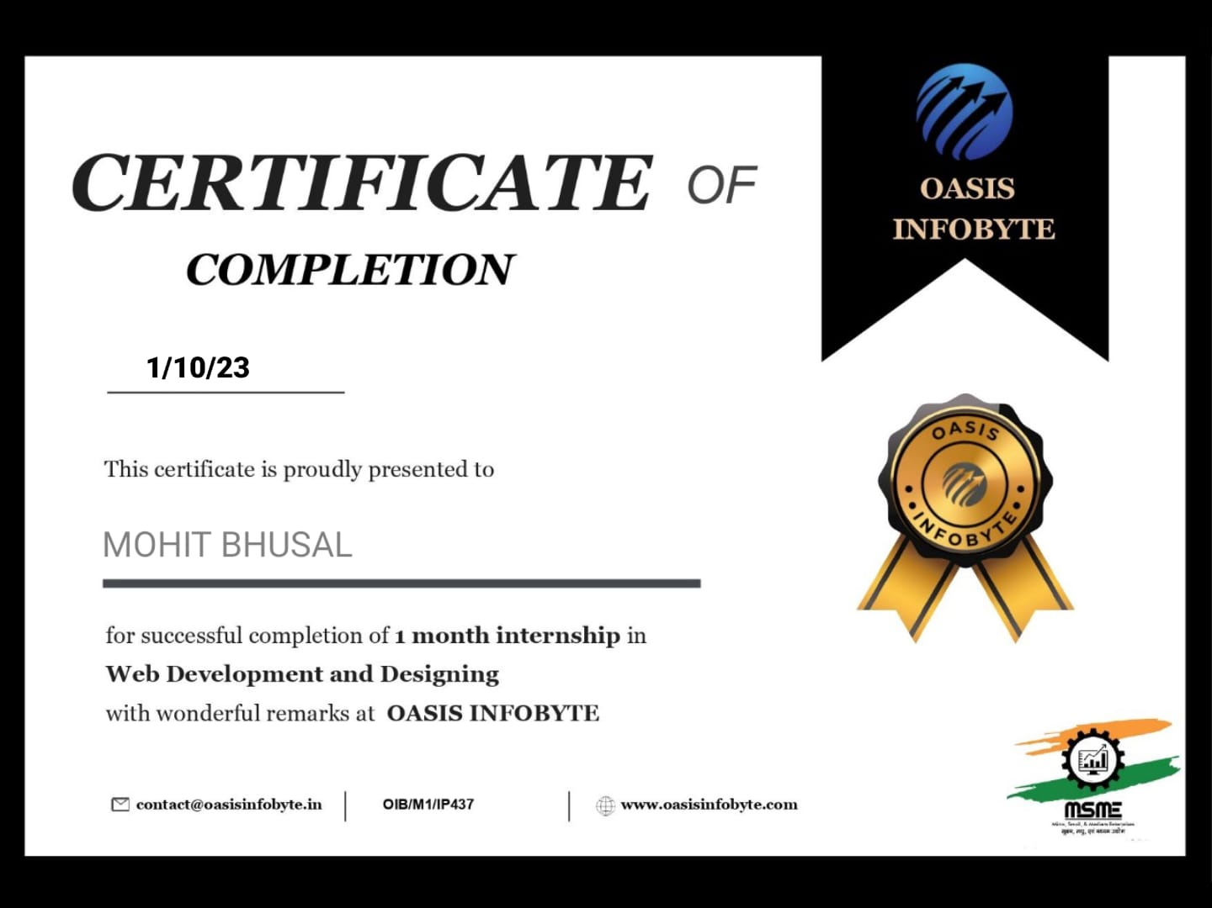

**SANJEEV AGRAWAL GLOBAL EDUCATIONAL UNIVERSITY, BHOPAL SCHOOL OF ENGGINEERING & TECHNOLOGY**

# ACKNOWLEDGEMENT

I would like to express my sincere gratitude to Ms. Divyan Singh Bhadauria for providing me with the opportunity to undergo my internship in the field of web development at Oasis Infobyte. The experience and knowledge gained during this internship have been invaluable in shaping my understanding of web technologies.

I extend my thanks to all the team members at Oasis Infobyte for their support and cooperation throughout my internship. Their guidance and mentorship have played a crucial role in enhancing my skills and knowledge in the field of web development.

I am also thankful to the School of Engineering & Technology, SAGE University, for providing me with the necessary facilities and resources to carry out this internship successfully.

A special thanks to Ms. Aaradhna Soni Internship Coordinator, School of Engineering & Technology, SAGE University, for their constant support and advice, which contributed significantly to the successful completion of my internship.

Finally, I would like to express my gratitude to my friends and family for their encouragement and support throughout this internship journey.

**Mohit Bhusal**

**20BTE3CSE10021**

# Table of Content

|  |  |  |
| --- | --- | --- |
| **S.NO** | **TITLE** | **PAGE NO** |
|  | ABSTRACT |  |
| **CHAPTER 1: INTRODUCTION** | |  |
| 1.1 | BACKGROUND |  |
| 1.2 | OBJECTIVE |  |
| **CHAPTER 2: PROJECT SCOPE** | |  |
| **CHAPTER 3: TECHNOLOGY STACK** | |  |
| **CHAPTER 4: PROJECT IMPLEMENTATION** | |  |
| **CHAPTER 5: SCREENSHOTS** | |  |
| **CHAPTER 6: LEARNING OUTCOME** | |  |
| **CHAPTER 7: CONCLUSION** | |  |
| **CHAPTER 8: FUTURE ENHANCEMENTS** | |  |
| **CHAPTER 9: REFERENCES** | |  |

**Abstract**

This report provides an overview of the web development internship undertaken by Mohit Bhusal at Oasis Infobyte. The internship focused on utilizing HTML, CSS, and JavaScript to create dynamic and responsive web applications. The report outlines the project scope, technology stack, project implementation details, and the learning outcomes of the internship.

**INTRODUCTION**

Embarking on a web development internship has been a journey of discovery and skill-building in the digital landscape. Over the course of this internship, I've immersed myself in the fundamental languages of the web – HTML, CSS, and JavaScript – unlocking the potential to shape and create dynamic online experiences.

In the fast-paced and ever-evolving world of technology, the importance of effective web development stands out as businesses and individuals strive to establish a compelling online presence. This internship has provided me with the opportunity to not only understand but actively contribute to the construction of visually appealing and functionally robust websites. From crafting the structure with HTML to refining aesthetics with CSS and incorporating interactivity through JavaScript, each phase of the web development process has been a hands-on exploration.

As I navigate this enriching journey, the fusion of creativity and technical proficiency in web development becomes evident, promising exciting possibilities in crafting seamless and engaging digital interfaces.

**Objective**

The primary objective of the internship was to gain practical experience in web development and enhance skills in creating visually appealing and functional web applications. The focus was on understanding the fundamentals of HTML for structuring content, CSS for styling, and JavaScript for adding interactivity to web pages.

**Project Scope**

The web development project undertaken during the internship involved creating a dynamic and responsive website. The scope included designing the user interface, implementing interactive features, and ensuring cross-browser compatibility. The project aimed to showcase proficiency in HTML, CSS, and JavaScript to create a seamless user experience.

**TECHNOLOGY STACK**

**HTML:**

HTML (Hypertext Markup Language) served as the foundation for structuring the content of the web pages. It provided a markup language to organize text, images, and multimedia elements.

**CSS:**

CSS (Cascading Style Sheets) was employed for styling the web pages, enhancing the visual appeal and ensuring a consistent look across the site. It facilitated the customization of colors, fonts, and layout.

**JavaScript:**

JavaScript was utilized to add dynamic and interactive elements to the website. It enabled the creation of responsive features, client-side validation, and enhanced user engagement.

**PROJECT IMPLEMENTATION**

**Design and Structure:**

The project involved designing a user-friendly interface with a clear navigation structure. HTML was utilized to define the structure of the web pages, incorporating headings, paragraphs, images, and other elements.

**Functionality:**

CSS was employed to style the elements, providing a visually appealing layout. JavaScript added functionality to the website, allowing for interactive features such as form validation, image sliders, and responsive navigation.

**SCREENSHOTS**

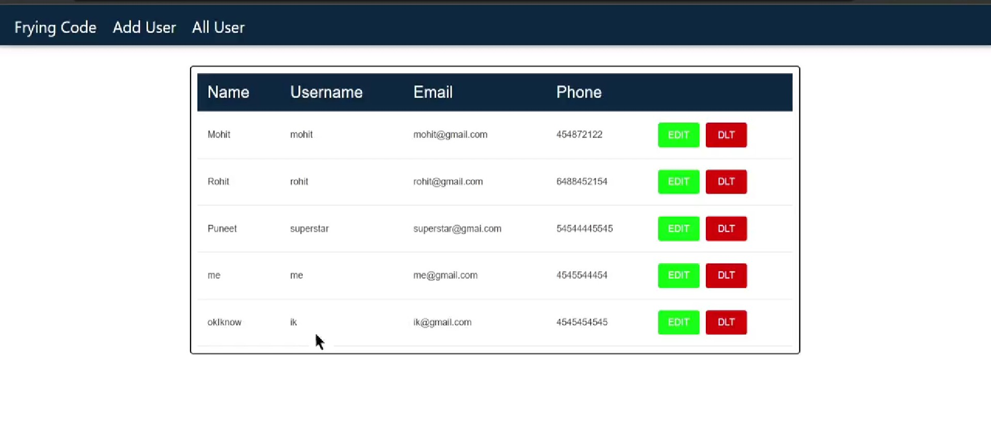

**Screenshot of project structure in git-hub**

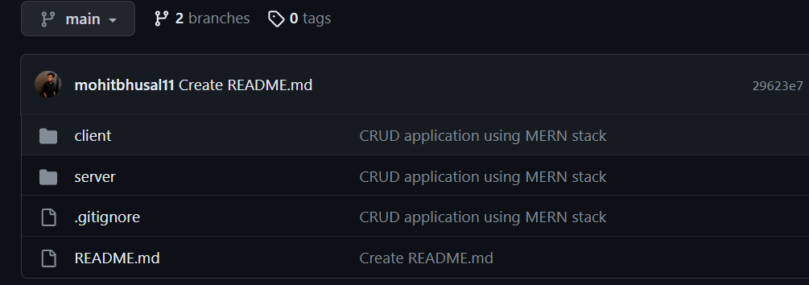

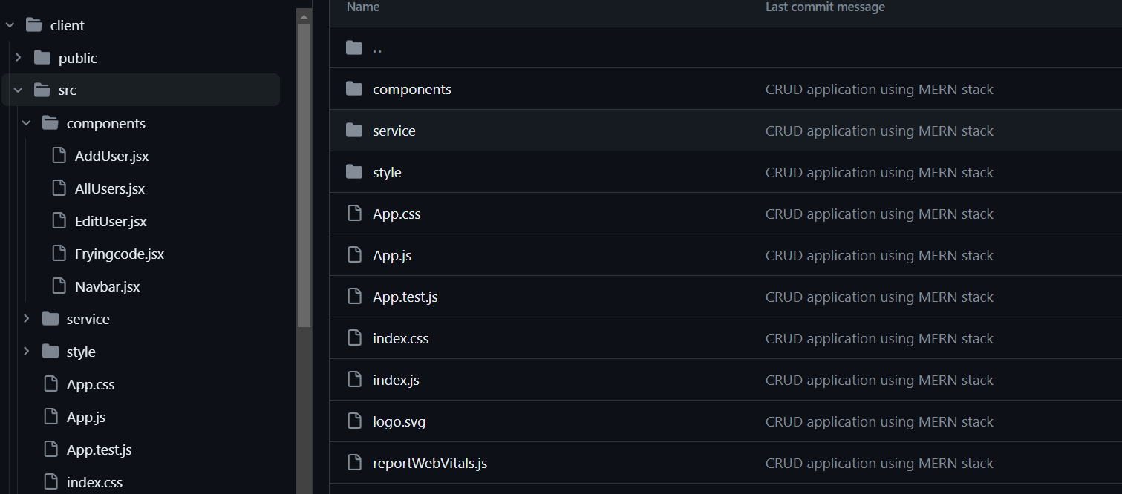

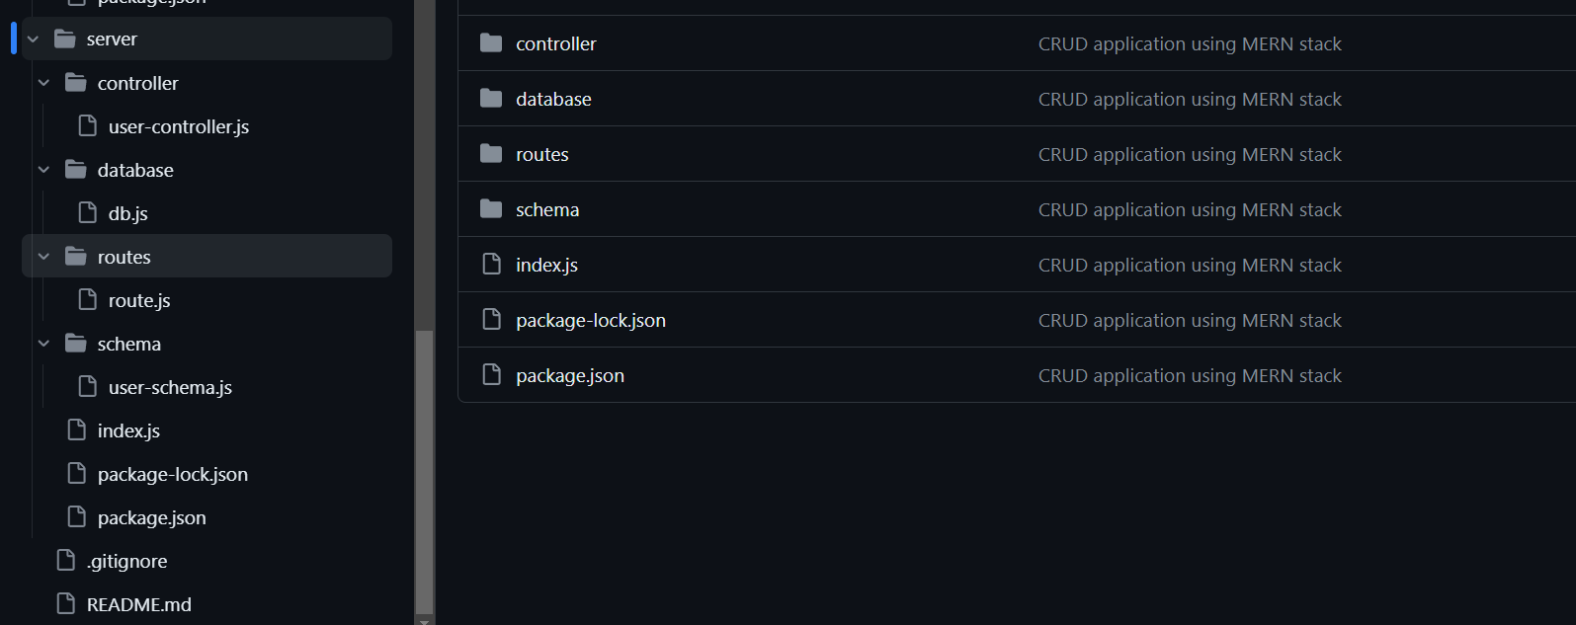

**LEARNING OUTCOMES**

The internship provided valuable insights and learning outcomes, including:

* Proficiency in HTML, CSS, and JavaScript.
* Understanding the principles of web development and design.
* Practical experience in creating responsive and interactive web applications.
* Enhanced problem-solving skills in addressing challenges related to web development.
* Collaboration and communication skills gained through working in a team environment.

**CONCLUSION**

The web development internship at [Company Name] has been a rewarding experience, providing hands-on exposure to key technologies in the field. The practical application of HTML, CSS, and JavaScript has enhanced skills and understanding, contributing to the development of a dynamic and user-friendly web application.

**FUTURE ENHANCEMENTS**

While the current project marks the successful completion of the internship, future enhancements could include:

Integration of additional features to enhance user engagement.

Implementation of backend functionalities for data storage and retrieval.

Optimization of code for improved performance.

Exploration of additional web development frameworks and libraries.

**REFERENCES**

MDN Web Docs. (https://developer.mozilla.org/)

W3Schools. (https://www.w3schools.com/)

JavaScript.info. (https://javascript.info/)

CSS-Tricks. (https://css-tricks.com/)